Step 1: Created a new project ( ismart project )

- Clicked on monitoring and switched to new project in stackdriver monitoring and created a new workspace

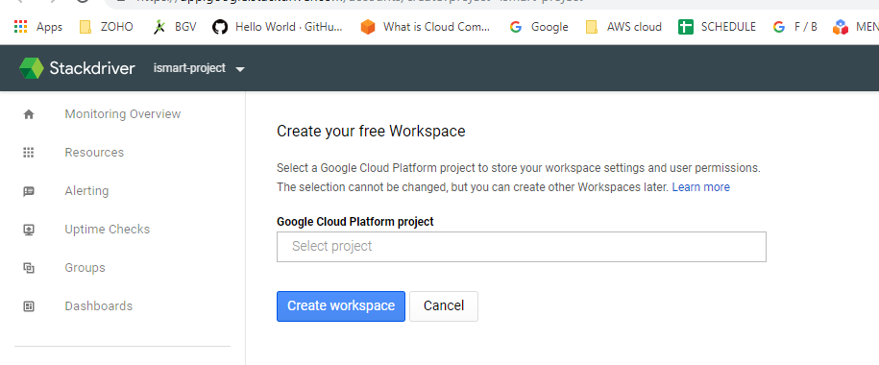

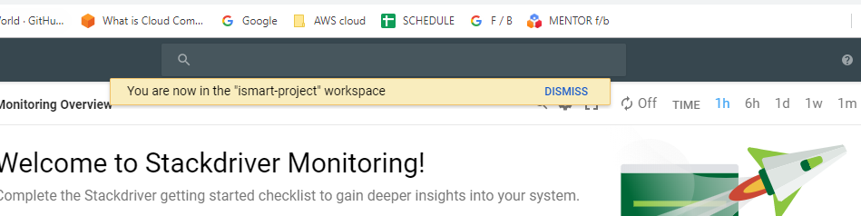

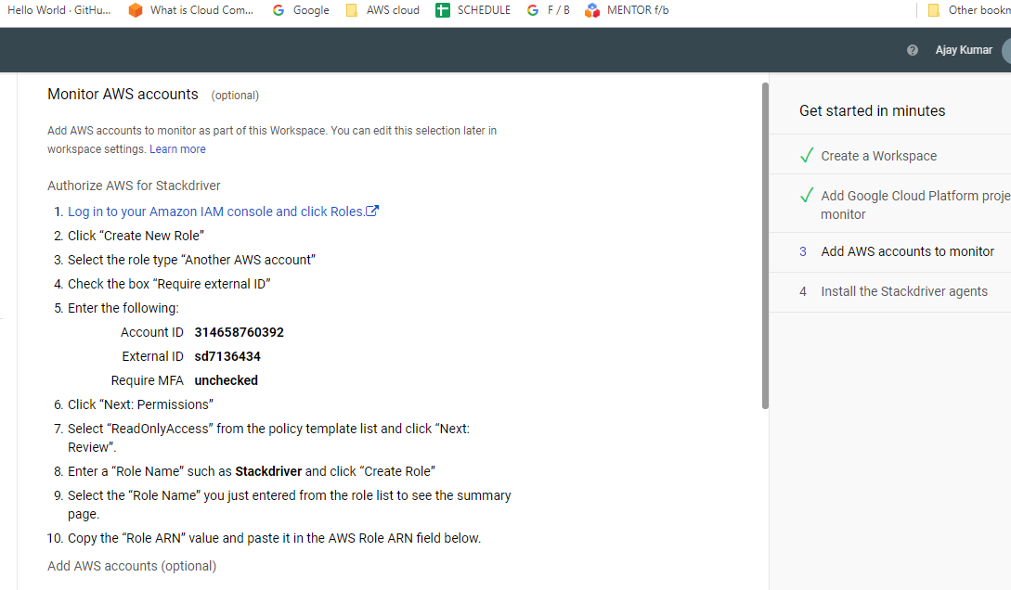

Logged into AWS and tried to create a role or we can edit an existing role ( either of ehich should have the Read only access permission ).

In order to add the AWS account to the workspace , used account ID and External ID provided by stackdriver monitor and added them as another AWS account in AWS so that only that specific account can use the role which we have created.

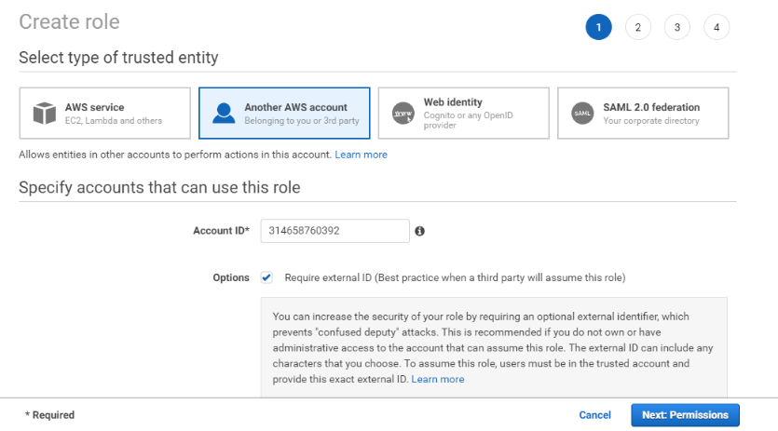

Creating a role

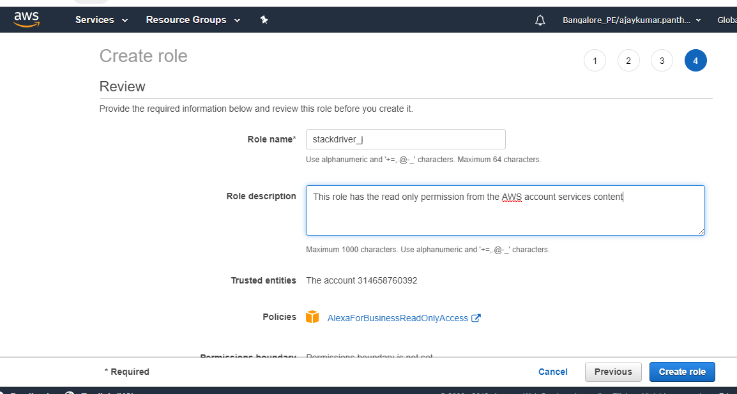

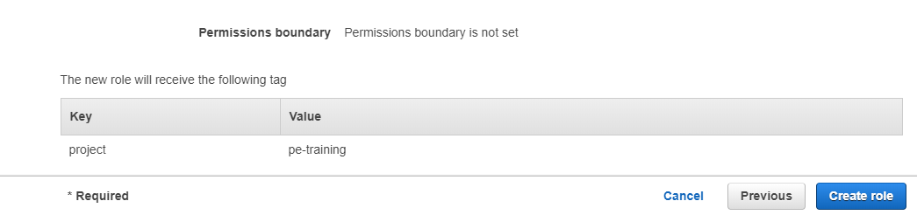

When we create a role, we get an ARN

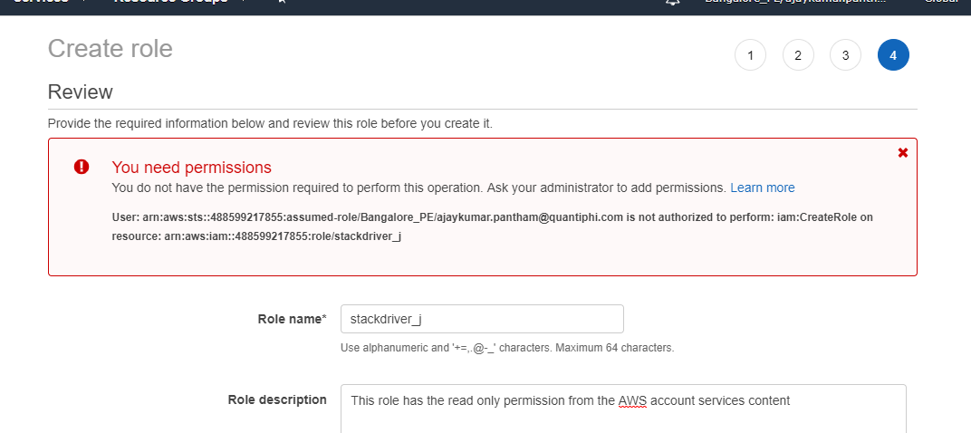

The ARN is used in stack driver monitoring workspace to add the AWS account.

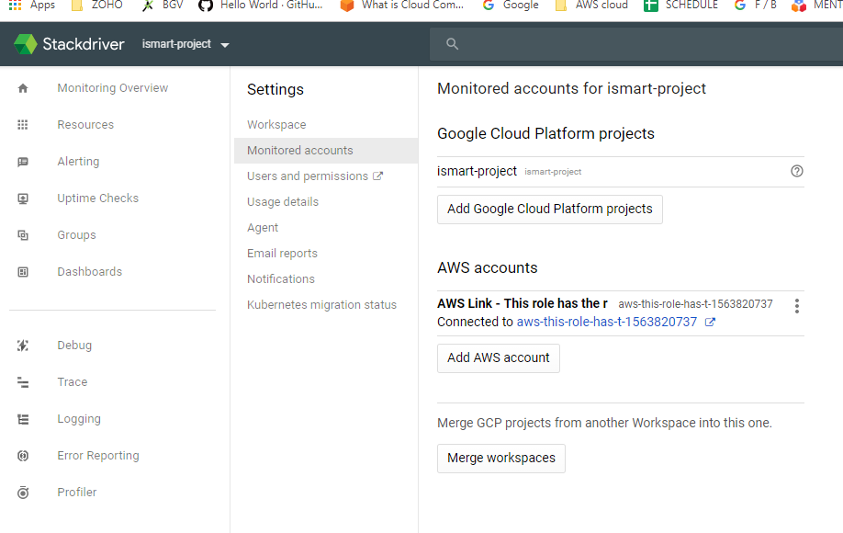

By doing this, we give stackdriver the permission and credentials to access the AWS resources and monitor them accordingly.

When we connect to an AWS account , monitoring creates an AWS connector project.
The monitored accounts page in workspace settings has now included the ID for this connector project.

AWS account description [AWS_account_number]connected to [connector_project_ID]

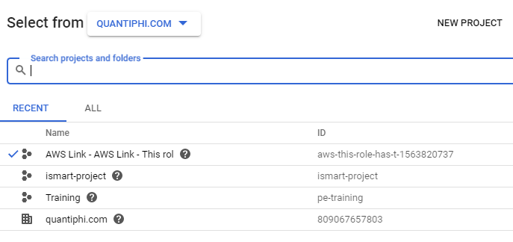
AWS connector project created.

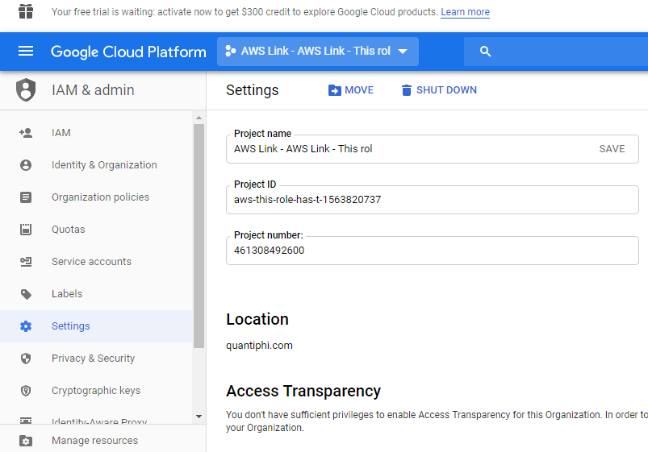

The connector project’s ID always begins with aws- and the project’s name always begins with AWS Link.

Authorizing the applications running on AWS to access the GCP services,we give them access to GCP service account having sufficient roles.

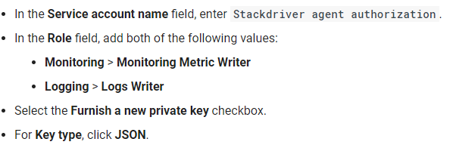

Created service account and downloaded the private key.

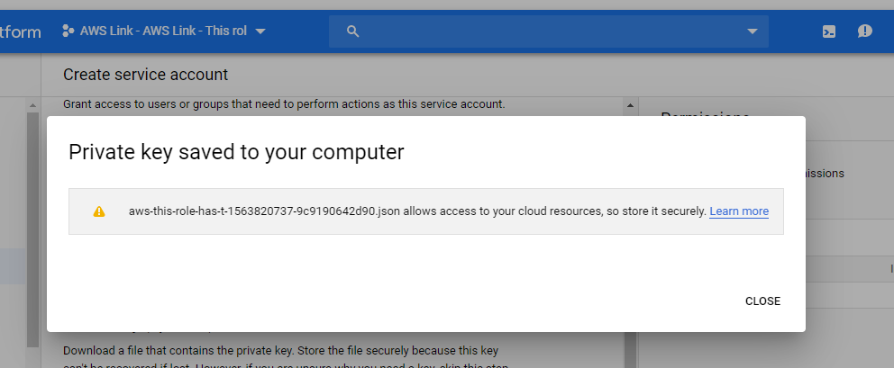

Added the service account to ec2 VM instance

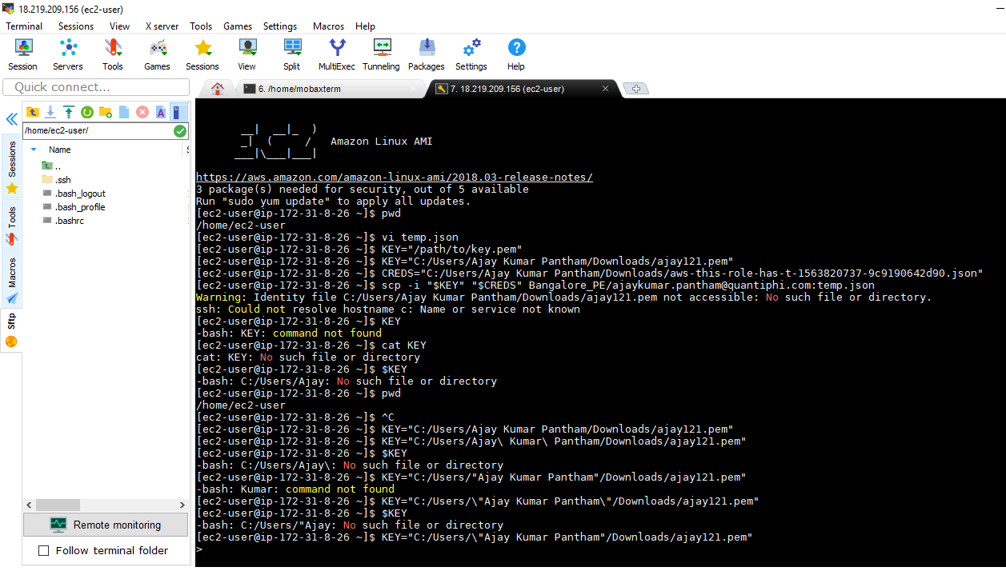

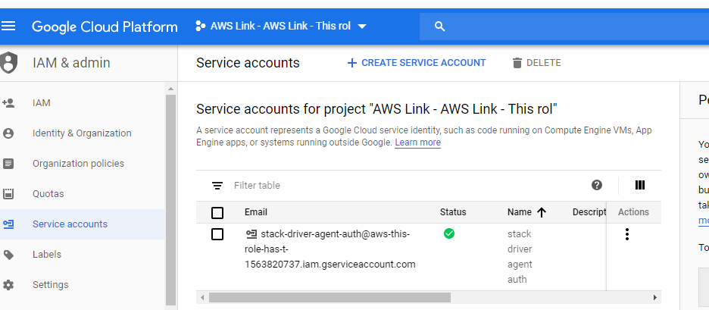
Installed the stackdriver monitoring and logging agent.

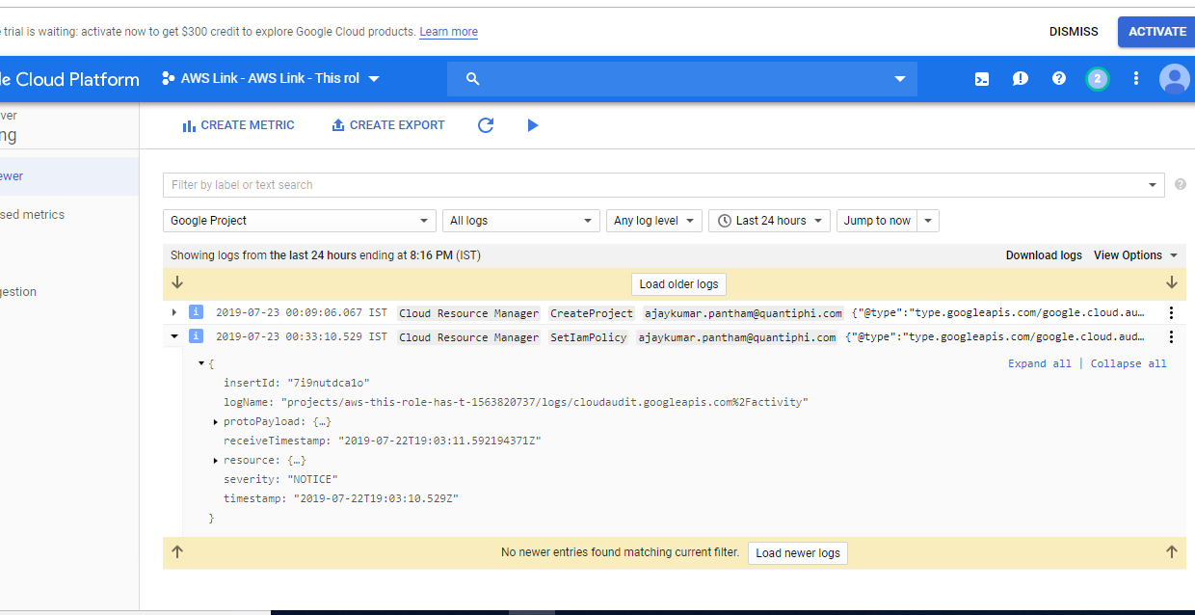

Created an uptime check

Created an alerting policy

View of Logging details

